**Establish your business details on Google**

The **Google knowledge panel** is a Google search engine results pages (SERPs) feature that displays brand and business information separate from general search results. This reading describes knowledge panels and provides set-up steps to establish business details.

**The Google knowledge panel**

Knowledge panels are information boxes that appear on Google when you search for entities such as people, places, organizations, or things. You can compare the knowledge panel to a person's personal identification card. Like an ID, the knowledge panel consolidates essential and official information regarding a business or brand. Knowledge panels are automatically generated, and information that appears in a knowledge panel comes from various sources across the web.

Below is an example that shows the details listed on the knowledge panel for Coursera.

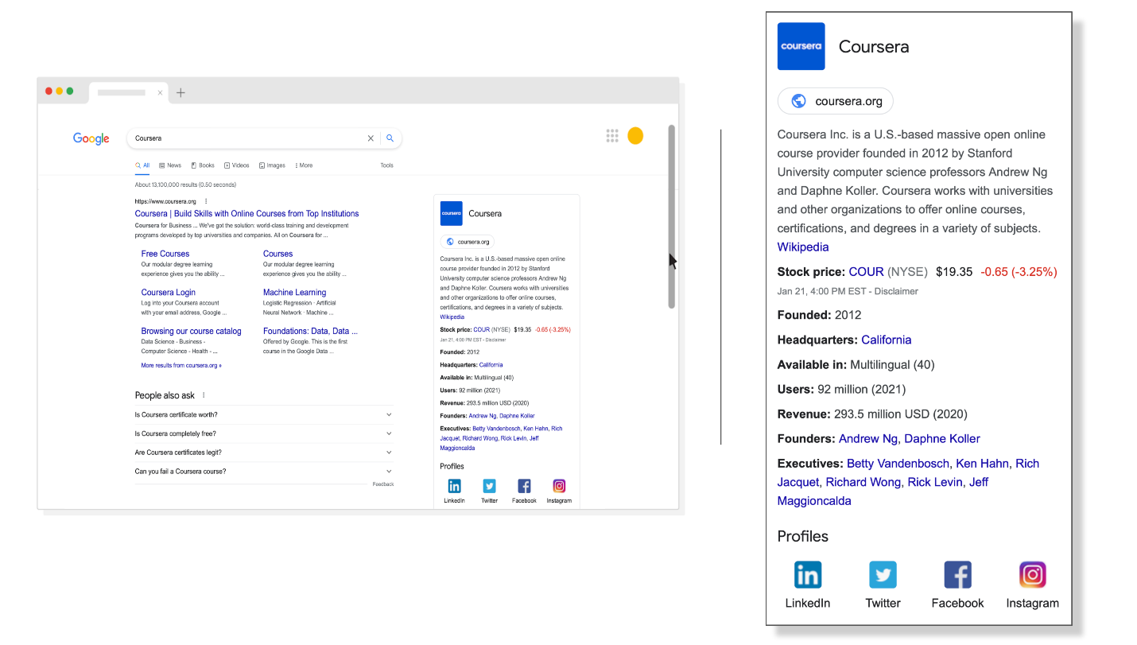

As displayed in the image, business details can include a(n):

* Official website link
* Site logo
* Brand industry
* Brand description
* Social profile links

Including this information makes it easier for searchers to identify a brand’s official site to find the exact information they were seeking.

**Set up business details on Google**

The following steps detail the process of setting up a brand’s business details for a knowledge panel on Google.

**Step 1: Create a Google Business Profile**

For business owners who run local brick-and-mortar businesses, like a restaurant or shopping retailer, the first step in establishing business details is to create a Google Business Profile.

**Google Business Profile** is a free tool that allows local businesses to tailor how their business information appears on Google Search and Google Maps. Owners can post hours of operation, their products and services, accept online orders, and more. You can create and manage a business profile directly in [Google Maps](https://www.google.com/maps) or [Google Search](https://www.google.com/).

**Step 2: Verify website ownership**

The next step is verifying the website ownership in [Google’s Search Console](https://search.google.com/search-console/about). **Search Console** is a powerful Google tool that helps you better understand how your website is performing, allows you to optimize visibility of your websites, and provides other services.

You’ll learn more about services the Search Console offers in a later section of the course.

Verifying your website through Search Console is important because it ensures that you have control over how your website is presented on Google and have access to sensitive Google Search data for your site.

**Step 3: Update the website’s Google knowledge panel**

After you're verified as an official representative, you can sign in to the Gmail account associated with the entity that you represent and update your Google knowledge panel information.

Updating these details overrides the publicly available information that Google algorithms automatically find and inputs for you.

**Step 4: Add structured data for rich results**

**Rich results** are Google Search results that go beyond the standard blue link. They can include carousels, images, or other non-textual elements. As a digital marketer, you’ll want to make sure your website is eligible for rich results because it helps your business stand out.

To help your business become eligible for rich results, you must add structured data. **Structured data** is a standardized format for providing information about a page and classifying the page content. It should be noted that adding structured data doesn’t automatically ensure that rich results will be added to your business’s search results page.

You can learn more about creating structured data by reading a document on the Google Search Central website titled [Understand how structured data works](https://developers.google.com/search/docs/advanced/structured-data/intro-structured-data).

Once you’ve added structured data, you can check its accuracy by entering your website’s URL on [Google’s Rich Results Test page](https://search.google.com/test/rich-results).

**Step 5: Highlight customer support methods**

Be sure to include ways that your website’s visitors can access helpful information or reach you for customer support needs. These include but are not limited to your contact number and email address.

**Key takeaways**

Displaying accurate information about your business helps you get recognized by search engine users quickly. Getting noticed helps direct your audience to your website to potentially complete a desired goal, such as making a purchase.

Learn more: [Add Business Details to Google](https://developers.google.com/search/docs/appearance/establish-business-details)